from google.colab import drive

# monta tu unidad de google drive

drive.mount('/content/drive')

# cambiamos el directorio de trabajo a la carpeta donde está almacenado el dataset

import os

os.chdir('/content/drive/My Drive/Colab Notebooks/HomoMex_2024/public_data_dev_phase')

tomar los archivos de dataset de traing y dataset

import pandas as pd

df_train = pd.read_csv("train.csv",  sep=',')

df_test = pd.read_csv("val.csv",  sep=',')

print('tamaño training',df_train.shape)

#print('tamaño test',df_test.shape)

print('tamaño test',df_test.shape)

df_train.head()

#df_val.head()

Tamaño para cada uno de los archivos

df_test.describe()

counts_train = df_train['label'].value_counts().to_dict()

print("Distribución en training:", counts_train)

counts_test = df_test['label'].value_counts().to_dict()

print("Distribución en test:", counts_test)

Distribución de clases

import matplotlib.pyplot as plt

fig, (ax_train, ax_test) = plt.subplots(1, 2, figsize=(20, 10))

fig.suptitle('Distribución de clases')

ax_train.bar(list(counts_train.keys()), counts_train.values(), width=0.4)

ax_train.set_xticklabels(list(counts_train.keys()), rotation=45)

ax_train.set_title('Conjunto de entrenamiento')

ax_train.set_xlabel('Clases')

ax_train.set_ylabel('Número de Instancias')

ax_test.bar(list(counts_test.keys()), counts_test.values(), width=0.4)

ax_test.set_xticklabels(list(counts_test.keys()), rotation=45)

ax_test.set_title('Conjunto de evaluación')

ax_test.set_xlabel('Clases')

ax_test.set_ylabel('Número de Instancias')

Graficamos los elementos de la clase del label

Label Codign

Label encoding esta tarea consiste en trasformar las labels en formato a texto a un formato numérico

from sklearn.preprocessing import LabelEncoder

from keras.utils import to_categorical

y_train = df_train['label'].tolist()

y_test = df_test['label'].tolist()

le = LabelEncoder()

print("antes de transform: ", y_train[:10])

y_train = le.fit_transform(y_train)

print("después de transform:", y_train[:10])

y_train_cat = to_categorical(y_train)

print("después de transform:", y_train_cat[:10])

y_test = le.fit_transform(y_test)

y_test_cat = to_categorical(y_test)

# guardamos el conjunto de labels y el número

LABELS = le.classes_

NUM_LABELS = len(LABELS)

idx2label={}

label2idx={}

for index, label in enumerate(LABELS):

    label2idx.update([(label, index)])

    idx2label.update([(index, label)])

# print(idx2label)

print('Labels:', label2idx)

print()

from keras.preprocessing.text import Tokenizer

X_train = df_train['content'].tolist()

tokenizer = Tokenizer(oov_token = True)

tokenizer.fit_on_texts(X_train)

tokenizer.word_index['<PAD>'] = 0

NUM_WORDS=len(tokenizer.word_index)

print("Tamaño del vocabulario ={}".format(NUM_WORDS))

capas neuronales de CNN y BLTS

from keras.models import Sequential

from keras.layers import Flatten, Dense, Embedding, Conv1D, MaxPooling1D

model = Sequential()

EMBEDDING_SIZE=300 #probar con 200, 300

model.add(Embedding(NUM_WORDS, EMBEDDING_SIZE, input_length=MAX_LEN))

model.add(Conv1D(filters=128, kernel_size=4, padding='same', activation='relu'))

model.add(MaxPooling1D(pool_size=2))

model.add(Conv1D(filters=64, kernel_size=3, padding='same', activation='relu'))

model.add(MaxPooling1D(pool_size=2))

model.add(Conv1D(filters=32, kernel_size=2, padding='same', activation='relu'))

model.add(MaxPooling1D(pool_size=2))

from keras.layers import Bidirectional, LSTM, Dropout, Dense

DROPOUT = 0.4

model.add(Bidirectional(LSTM(60, return_sequences=True, recurrent_dropout=0.2)))

# Añadimos una capaz droput después de la capa bilstm

model.add(Dropout(DROPOUT))

model.add(Bidirectional(LSTM(32, recurrent_dropout=0.2)))

model.add(Dropout(DROPOUT))

model.add(Dense(60, activation='relu'))

model.add(Flatten())

model.add(Dense(50, activation='relu'))

model.add(Dense(NUM_LABELS, activation='softmax'))

model.compile(loss='categorical_crossentropy', optimizer='adam', metrics=['accuracy'])

model.summary()

resultados del modelo pre entrenado en basa a los valores

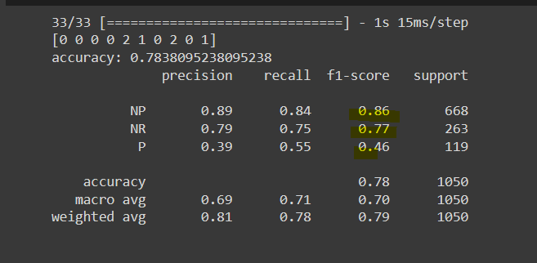

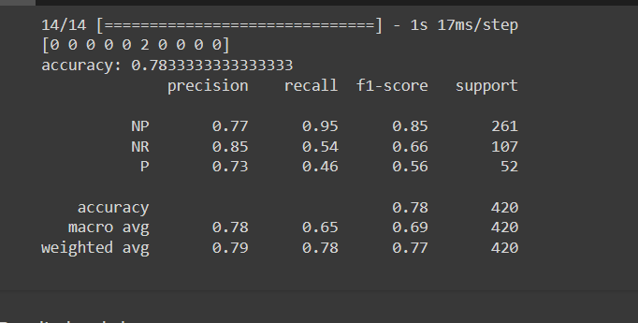15 de abril del 2024

Capas de la neurona

from keras.models import Sequential

from keras.layers import Flatten, Dense, Embedding, Conv1D, MaxPooling1D

# campa de CNN

model = Sequential()

EMBEDDING_SIZE=300 #probar con 200, 300

model.add(Embedding(NUM_WORDS, EMBEDDING_SIZE, input_length=MAX_LEN))

model.add(Conv1D(filters=128, kernel_size=4, padding='same', activation='relu'))

model.add(MaxPooling1D(pool_size=2))

model.add(Conv1D(filters=64, kernel_size=3, padding='same', activation='relu'))

model.add(MaxPooling1D(pool_size=2))

model.add(Conv1D(filters=32, kernel_size=2, padding='same', activation='relu'))

model.add(MaxPooling1D(pool_size=2))

# capa de bilstm

from keras.layers import Bidirectional, LSTM, Dropout, Dense

DROPOUT = 0.4

model.add(Bidirectional(LSTM(60, return_sequences=True, recurrent_dropout=0.2)))

# Añadimos una capaz droput después de la capa bilstm

model.add(Dropout(DROPOUT))

model.add(Bidirectional(LSTM(32, recurrent_dropout=0.2)))

model.add(Dropout(DROPOUT))

model.add(Dense(10, activation='relu'))

sofmax realizado

model.add(Flatten())

model.add(Dense(50, activation='relu'))

model.add(Dense(NUM_LABELS, activation='softmax'))

model.compile(loss='categorical_crossentropy', optimizer='adam', metrics=['accuracy'])

model.summary()

